KRAZYBEE SERVICES LIMITED RCU VERIFICATION REPORT
(SKY LINE RISK AUDIT SERVICES)
STATE | TN
BRANCH | HOSUR
LOAN ACCOUNT NUMBER | 1614001
PRODUCT | LAP
APPLICANT NAME | PALANI B
CO-APPLICANT NAME | SABETHA B
LOAN AMOUNT | NA
SAMPLED DOCUMENTS | PAY SLIP CHECK
PICK UP CRITERIA | Mandatory
SAMPLED DATE | 28-09-2026
REPORT DATE | 28 -09-2026
TAT | 0
DISBURSEMENT TYPE | PRE

AGENCY DEDUPE STATUS REMARKS | NO ADVERSE FOUND
VISITED RESIDENCE ADDRESS | NA
NEIGHBOUR / THIRD PARTY CHECK / REFERENCE REMARKS  FOR RESIDENCE ADDRESS | NA
RESIDENCEADDRESS VERIFICATION REMARKS | NA

VISITED BUSINESS ADDRESS | NA
NEIGHBOUR / THIRD PARTY CHECK / REFERENCE REAMRKS  FOR BUSINESS ADDRESS | NA
BUSINESS ADDRESS VERIFICATION REMARKS | NA
DOCUMENTS VERIFICATION CHECK REMARKS | Visited the given address and met the proprietor, Mr. Ravi Chandran. He confirmed that the applicant has been working as a saleswoman in the said concern for the past two years. Nature of business is a grocery shop. Total staff strength is two, of whom one was seen. Salary is received through hand cash. The salary slip was issued and signed by the proprietor; however, the salary mentioned in the slip was incorrect. The actual salary is 15,000, whereas 25,000 was mentioned in the salary slip. The same was cross-verified with a nearby colleague, who confirmed the applicant's employment details and actual salary of 15,000. Hence, the salary slip details are inconsistent. Status: Negative.
TRC /ANY OTHER CHECKS REMARKS | NA
RCU VERIFICATION STATUS | NEGATIVE

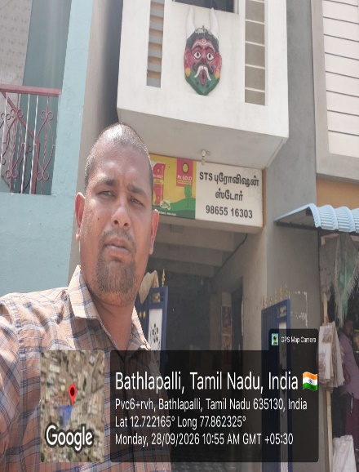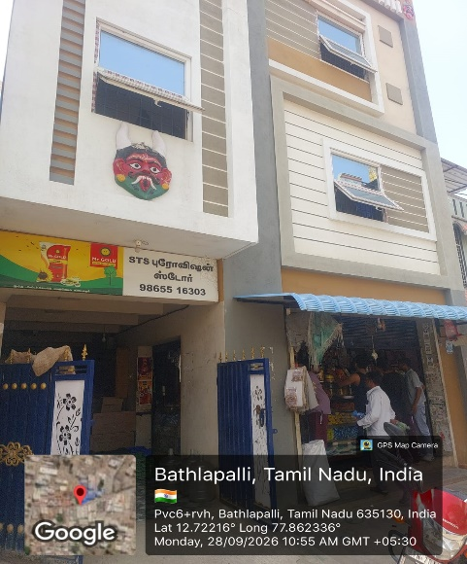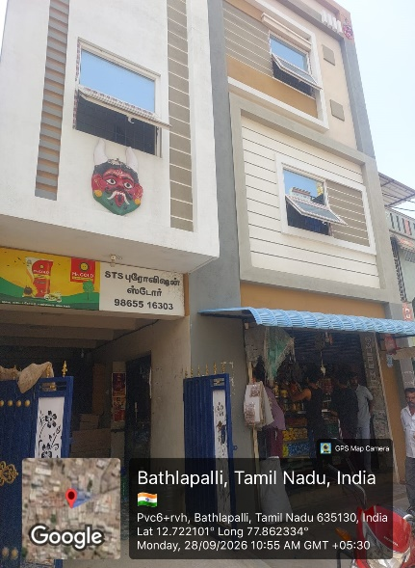

SIGNATURE & SEAL THE AGENCY

